**Environmental factors are predominant over intertidal communities along Southeast Brazil**

Cesar A. M. M. Cordeiro1*, André Pardal2,3, Luis Giménez4, Áurea M. Ciotti5, Stuart R. Jenkins4, Michael T. Burrows6, Gray Williams7 & Ronaldo A. Christofoletti3

1Laboratory of Environmental Sciences, Universidade Estadual do Norte Fluminense (UENF), Av. Alberto Lamego 2000, 28013-602, Campos dos Goytacazes, RJ, Brazil

2Center of Natural and Human Sciences, Federal University of ABC (CCNH/UFABC), Rua Santa Adélia 166, Santo André, SP, 09210-170, Brazil

3Institute of Marine Science, Federal University of São Paulo (IMar/UNIFESP), Rua Dr Carvalho de Mendonça 144, Santos, SP, 11070-100, Brazil

4School of Ocean Sciences, Bangor University, Menai Bridge, Anglesey, LL59 5AB, UK

5Center of Marine Biology, University of São Paulo (CEBIMar/USP), Rod. Manoel Hipólito do Rego, km 131.5, São Sebastião, SP, 1160-000, Brazil (AP as a visiting PhD student)

6Department of Ecology, Scottish Association for Marine Science, Scottish Marine Institute, Oban, Argyll, PA37 1QA, UK

7The Swire Institute of Marine Science, Department of Ecology & Biodiversity, The University of Hong Kong, Pokfulam Road, Hong Kong, Special Administrative Region of China

*email: cammcordeiro@pq.uenf.br

**Abstract**

Rocky shore communities are constantly under the effect of environmental stressors that modulate biological interactions (*e.g*., competition, predation, settlement) which shape intertidal communities. We investigated the associative patterns between abiotic and biotic variables and populational aspects of dominant intertidal species on rocky shores of the southwestern Atlantic to understand the relative contribution of those drivers to patterns at different scales. In 2015, a survey was carried out in 62 rocky shores, corresponding to ~50% of the rocky shore extension of the Brazilian coast. The effect of wave exposure, sea water temperature and shore complexity (roughness, inclination and extension) were tested in relation to size, density or cover of dominant intertidal species, regarding expected effects of trophic relationship among those five species. Abiotic factors (SST and wave exposure) were the prevalent predictors of intertidal populational parameters related to large scaled variability. The reflex of bottom-up and top-down effects was observed at the smallest spatial scale for a few sampling sites. Three main trophic-oceanographic systems were observed: a cold-oligotrophic system at northern sites (Lagos region), a eutrophic system associated to large estuaries and urban zones (Santos and Guanabara bays) and, a transitional warm-water system found in between the two eutrophic centres. Along the observed gradients, larger individuals were generally found in the upwelling system, while small filter-feeders dominated the eutrophic systems. Few studies comprised large-scale patterns in rocky intertidal communities along the Southwestern Atlantic and the present is the first dealing with multi-taxa populational parameters, adding to the comprehension of links between environmental variability and biological responses at multiple spatial scales.

**Introduction**

Coastal environments are natural transition zones between terrestrial, freshwater, and marine ecosystems, providing an open laboratory to observe the functioning and integration of biological and abiotic factors over shore communities. The composition and dynamics of the communities in these habitats are directly influenced by physical (e.g., wave exposure, temperature, salinity, and tidal range) and biological factors (e.g., competition, predation, herbivory, settlement, and colonization). The integration of these factors results in bottom-up and top-down effects on communities, which interact with lateral modifiers (abiotic factors) to regulate the diversity, abundance and distribution of producers and consumers (Menge 1992, 2000; Hawkins *et al*. 2020). In addition, both processes vary at different spatial scales, from meters to hundreds of kilometres (Navarrete *et al*. 2005; Burrows *et al*. 2009), which makes clear the importance of situating the spatial context in which such processes act on.

Top-down control emerge from the effect of consumers on prey populations, influencing the structure of communities by directly altering the functioning of ecosystems (Leonard et al. 1998). Experimental work throughout the world reported the influence of herbivores on the dynamics of macro- and microalgae in the intertidal (Menge *et al*. 1999; Aguillera & Navarrete 2007; Jenkins *et al*. 2008). Likewise, carnivores have large importance controlling lower trophic levels and associated with intertidal trophic cascades (Paine 1966, Wootton 1995). On the opposite direction of the food chain (*i.e.*, bottom-up effects), primary producers play an important role in benthic ecology on rocky shores (Underwood 1979, Bustamante *et al*. 1995). For instance, biofilms can be a limiting resource for grazing herbivores (Thompson *et al*. 2004; Christofoletti *et al*. 2011a) and influence settlement of seaweed propagules and larvae of marine invertebrates (Wahl 1989). The abundance and growth of primary consumers are directly related to variations in the primary productivity of phytoplankton, and recruitment, through the relationship between pelagic larval stages and coastal advective processes (e.g., Connolly *et al*. 2001; Leslie *et al*. 2005). In this context, variations in food and propagule supplies are seen as the basis for trophic interactions (Menge 2003; Menge & Menge 2013, 2019) and the transfer of energy to the upper links of the trophic chain (Nielsen & Navarrete 2004).

The effects of top-down and bottom-up processes have been widely studied on rocky shores worldwide. Still, the southwestern Atlantic systems have been poorly evaluated and done mostly at local scales. The patterns of association among these species had indicated higher densities of filter-feeders in highly wave-exposed shores (Coutinho 1995, Christofoletti *et al*. 2011a, Pardal *et al*. 2021), while grazers are usually found on more structurally complex shores (Apolinário *et al*. 1994). Sessile taxa may also influence the larger presence of predators at more exposed sites (Christofoletti *et al*. 2011b), which reinforces the importance of evaluating the contribution of biotic variables to communities’ patterns. Here, based on the most abundant and usually dominant organisms in the intertidal zone (Christofoletti *et al*. 2011a), we investigated the associative patterns between abiotic and biotic variables on population structure of dominant rocky shore intertidal species of Southeastern Brazil marine ecoregion (Spalding *et al*. 2007) to understand the relative importance of those associative patterns at different scales. Thus, we evaluated consumers and prey estimates (*i.e.*, size, abundance or cover) in models according to expected trophic relationships to observe the potential correlative effects of tested variables in indicative patterns of bottom-up or top-down processes. We hypothesized that the populations of the intertidal species are affected by both bottom-up and top-down effects. Therefore, we expected that availability of producers would increase the abundance and size of their consumers (*i.e*., bottom-up model). Further, we expected that the abundance and size of prey would be smaller where predators are more abundant and larger (*i.e*., top-down model). Lastly, we predicted that abiotic factors would affect the intertidal species’ population structure as they can have direct and indirect effects on recruitment, survival, growth and behaviour (REF).

**Material and Methods**

*Study area*

Between April and September 2015, surveys were carried out in 62 rocky shores along the Southeast coast of Brazil (Figure 1), comprising a linear length of approximately 530 km. This distance corresponds to roughly 50% of the continuous rocky extension of the Brazilian coast. The study area is dominated by a microtidal regime, with a mean sea level around 0.7 m above local chart datums and an average tidal range of about 1.4 m. Biological data were haphazardly sampled in the intertidal zone along an area of approximately 100 m horizontal distance during low tides. Sites were selected within six main regions with distinct natural conditions and anthropogenic influence: (i) Baixada Santista, (ii) São Sebastião Channel, (iii) Ubatuba, (iv) Costa Verde, (v) Rio de Janeiro, and (vi) Lagos. Details of each subregion can be found in Pardal *et al.* (2021). Briefly, Baixada Santista and Rio de Janeiro subregions are two of the most important metropolitan centers of Brazil, which concentrate highly anthropically influenced sites due to higher degree of urbanization and the presence of ports, shipyards and industrial complexes. The Ubatuba and Costa Verde subregions have the least populated areas, while São Sebastião Channel and Lagos have an intermediate level of anthropic influence. Along the study area, colder waters are found northwards due to upwelling events in the Lagos subregion (Valentin 2001), and higher primary productivity is commonly found associated with large urbanized bays in Baixada Santista and Rio de Janeiro. We surveyed sites after the period of more frequent and intense upwelling events (Valentin 2001), which may have enhanced SST effects.

*Sampling of intertidal species*

Populations of filter-feeders (the mussels *Mytilaster solisianus* and *Perna perna*, and the barnacle *Tetraclita stalactifera*), grazers (the limpet *Lottia subrugosa* and the periwinkle *Echinolittorina lineolata*) and a carnivorous predator (whelk *Stramonita brasiliensis*) were sampled through photos, scraping or by manual collection in the midlittoral and supralittoral zones of each site. Abundance of the mussel *M. solisianus* was estimated as percentage cover in photos of 625 cm² (n = 10) taken at the upper midlittoral, using a 100 regular intersection grid. The presence of *P. perna* was quantified from quadrats (625 cm², n = 6 - 12) randomly taken at the low midlittoral level. In laboratory, mussels *M. solisianus* scraped from 100 cm² parcels were photographed for measuring. The density of the barnacle and limpets was measured from images of 100 cm² (n = 15). In each image, whenever possible, 15 individuals of barnacles and all limpets were measured. For limpets, only adults (< 0.5 mm, Ferreira *et al*. 2014) were used in the models, as well as outliers in size of barnacles (mean ± 2*SD) were not included in models to decrease the noise of recent recruitment events and unusually large individuals (< 0.1% of total abundance). Total abundance of whelks per site was estimated collecting specimens in quadrats of 625 cm² (n = 20). Total abundance of periwinkles per site was accessed by one person picking specimens by hand for five minutes. The whelks and periwinkles were measured in the laboratory with caliper and from digital images, consequently. The largest length of shell or operculum was the representative measure of size for mollusks and the barnacle, respectively.

*Environmental predictors*

Nearshore oceanographic data was obtained from satellite images distributed by NASA Ocean Biology Processing Group (<https://oceancolor.gsfc.nasa.gov>). Images from MODIS-Aqua (level-2, 1-km resolution) were used to estimate chlorophyll-a concentration (Chl-a), sea surface temperature (SST) and freshwater discharge (FWD) from images within the 1-year period before field samplings at each site. Data were extracted using a 5x5 (Chl-a and FWD) or 9x9 (SST) pixel buffer centered on coordinates of each site (Figure 1). SST was derived from longwave thermal radiation (11-12 μm), while the ratio between bands (443, 469, 488 and 555 nm) was used for calculating a proxy for FWD and Chl-a Detailed information on image selection and data processing are described in Pardal *et al.* (2021).

*Shore topography*

In each shore, we characterized shore topography by measuring substrate roughness, extension and inclination. For estimating substrate roughness, we used the chain method (Frost et al. 2005), which consists in laying a chain of 3 m in length from the upper limit of the infralittoral fringe up in a straight line over the rock surface, allowing it to follow all contours and crevices. The ratio between the known length of chain and distance covered over the ground resulted in the roughness index. Extension was measured as the distance between the lower limits of the supra- and mesolittoral (mid-shore), following the limits of distribution of dominant species *Chthamalus bisinuatus* (high mid-shore) and *Tetraclita stalactifera* (lower mid-shore). Finally, we performed measurements of substrate inclination with an inclinometer in the high, intermediate and lower mid-shore. For all variables (roughness, extension and inclination), five replicates were haphazardly measured in each shore.

*Wave exposure*

The likely level of wave exposure of the shores was based on the model of Burrows (2012), and was used to produce a wave exposure map for the coastline of Southeast Brazil (see Pardal *et al.* 2021) based on total wave fetch. For every coastal cell, wave fetch was calculated as the distance to the nearest land around each point on the map for up to 200 km away from the coastline. The distance to the nearest land was determined in 32 (11.25°) angular sectors for each 200-m grid cell in the model domain. For each cell, the final wave fetch value was the sum of the fetch values across all 32 sectors. Therefore, such value may be expressed as the number of cells (0 to 32,000 cells), distance in kilometres (0 to 6,400 km) or as log10 of number of cells (0 to 4.5). We use the latter unity in this study. Summed wave fetch was extracted for a circular area of 500 m radius centred on the coordinates of each location.

*NDVI - Normalized Difference Vegetation Index*

The estimates of biofilm biomass were derived from NDVI (Normalized Difference Vegetation Index) measurement using the same technique applied by Pardal-Souza *et al*. (2017). The NDVI values were based on the analysis of 15 digital images (15 x 15 cm), taken randomly at the high and low mid-shore levels in each of all 62 shores using a near-infrared-enable digital camera. From the difference in values of blue, green and near-infrared we extrapolate NDVI values (Murphy *et al*. 2009). The NDVI value is an indirect measure of biofilm biomass from a ratio between absorbed and reflected light spectrum by chlorophyll molecules (Bryson *et al*. 2013). The result is an index from -1 to 1, where positive values are related to microalgae biomass, 0 is the absence of chlorophyll-a in biofilm (*i.e.* non-detectable microalgae), and negative values indicated high absorption (*e.g.* values obtained in the water). As we took all measurements over mainly reflective surfaces (*i.e*., rocks), the few negative values observed in samples (9.6% of samples) were not included in average values used in the analysis.

*Data analysis*

*Spatial scales of variation*

We used estimates of variance components for testing spatial scales of variability in population parameters of investigated species and environmental predictors. For each response variable, we fitted a fully nested random model considering the factors representing variation at different spatial scales: region (100s of kilometres), subregion (10s of kilometres) and location (kilometres) (figure 1). Models started with the fully nested random model and included all combinations of random effects with two or only one term. Models were estimated with REML (Zuur et al., 2009). The best model was chosen based on the comparison of AIC scores. We did not consider models with singular fit on model selection.

*Effect of environmental predictors on population parameters*

Before investigating relationships among environmental variables on population parameters, we checked for collinearity among variables using correlation matrices (Spearman’s correlation coefficient) and applying the VIF (variance inflation factor, *corvif* function). Variables with r ≥ 0.65 and/or VIF > 4 were not included in models (Zuur *et al*. 2009). The VIF values were high for inclination and extension, but inclination was less correlated with other variables, thus extension was not included the analysis. We applied a Redundancy Analysis (RDA) to biotic data in relation to abiotic variables to depict general patterns along spatial scales using average values per site, where populational parameters were standardized by their range, and environmental drivers were scale to zero mean and unit variance using *decostand* function from *vegan* package (Oksanen *et al*. 2019). The significance of axes and the relative contribution of each environmental variable were tested with a Monte-Carlo test (4999 unrestricted random permutations under the reduced model) using the functions *anova.cca* and *ordistep* from *vegan* package.

The effect of environmental predictors (averaged values by site) on size, density or cover (depending on species) were tested using initially generalized linear mixed effects models (GLMM) with Gaussian (identity link), negative binomial (log link) and binomial (logit link) distributions, respectively. Prior to analysis we applied Spearman rank correlations between size and density or cover of averaged values by site for tested species to check for explicit density-dependent effects and no correlation was found (p > 0.05). Once we selected the best random structure for models, the fixed structure was selected through maximum-likelihood (ML) estimation. To do so, we performed a backwards stepwise removal of non-significant fixed effects. In each run, the term with largest p-value or lowest t-value (abundance) was removed. The final mixed model was selected once we could not drop any non-significant term (p > 0.05). In cases where residuals indicated poor fit, models were reduced to mean values of dependent variables at site level and ran without the random term. We detected non-linear relationships between dependent variables and predictors for *M. solisianus* size and cover, and *L. subrugosa* size, and those were fitted using generalized additive models (GAM), following the same model selection procedure. Final best model was then validated through inspection of residual plots against fitted values and selected environmental variables, as well as residuals histogram (see appendix A). All model selection procedures were based on the best model adjustment and parsimony. Analyses were performed in R software (R Core Team 2020) using the *glmmTMB* (Brooks *et al*. 2017) and *mgcv* (Wood 2016) packages.

All models were initially built including a random term (site, subregion and region) and a fixed term for the abiotic variables (Chl-a, FWD, wave fetch, SST, inclination and roughness). For the predatory species (*Stramonita* *brasiliensis*), the preys’ parameters (size, density or cover) were also included as predictors in the models. The presence of the mussel *P. perna* was also used as a predictor of the predator population structure. We did not build models to predict the abundance and size of *P. perna* because this species is harvested along the study area (Carranza *et al*. 2009) and we could not quantify the effect of human intervention. Similarly, for prey species (*T. stalactifera*, *L. subrugosa* and *M. solisianus*) the mean values of size and density of the predatory species were included in models to depict the relative contribution of top-down influence. Finally, for grazing species (*i.e*., *L. subrugosa* and *E. lineolata*) the NDVI values corresponding to each tidal stratum was included in models.

*Spatial models*

The last step was testing for spatial autocorrelation through visual plots of model residuals versus spatial coordinates, predicted residuals (DHARMa package, Hartig, 2020) and model selection. We found spatial patterns on the residuals corresponding to *L. subrugosa* and *T. stalactifera* densities. Therefore, we checked if the best model explaining variations in those variables was robust to spatial autocorrelation in the residuals using spatial models through INLA, following steps detailed in Zuur *et al*. (2017, chapters 10 and 12). Those models were based on data averaged by location, Gaussian residuals and using a Gaussian Markov random field (GMRF) based on the Matérn correlation to model the spatial autocorrelation, using the methods detailed in Pardal *et al*. (2021). Briefly, the GMRF was constructed through a mesh (figure S1, supplementary material) limited by the sea and the coastline. The mesh was constructed with triangles (maximum edge: inner triangles = 4 km; outer triangles = 20 km; cut-off sides = 0.8 km). We used semi-diffuse penalized complexity priors to specify the parameters of the Matérn correlation. We run the models with two different values of the maximum range (500 and 1000 km), *e.g.*, P (MaxRange < 1000km = 0.95) and a value for the prior of the marginal standard deviation (σu) depending on the response variable, corresponding to the expected standard deviation based on the range of values of the data and assuming Gaussian distribution. We also explored the effect of changing priors for the range (MaxRange = 100) but such models had indication of overfitting, as shown by larger effective number of parameters and lower number of equivalent replicates than the previous models. All spatial models removed the spatial autocorrelation in the residuals (see appendix A) irrespective of the change in the priors for the range.

**Results**

As a general pattern, we observed an overlap in subregions (figure 2) and, consequently, between Regions 1 and 2. The RDA indicated guidance to a first interpretation of general patterns, although only 17.4% (adjusted R2) of constrained variance was associated with wave fetch, SST and freshwater index in the reduced model (figure 2 and table S1; ANOVA, *F*3, 54 = 4.99, p < 0.001). Axis 1 (55.01% of explained variance; *F*1, 54 = 10.99, p<0.001) was directly related with all significant variables in the reduced model, while Axis 2 (30.56%; *F*1,188 = 31.03, p < 0.001) showed a negative relationship with freshwater index and wave fetch (figure 2). Baixada Santista and SSCh had warmer (SST) and more productive (Chl-a), and were opposite to Lagos and Rio de Janeiro with colder and more oligotrophic waters but higher NDVI values (figure 2 and figure S2). Ubatuba and Costa Verde are transitional subregions (figure 2), with variable values for most drivers and higher shore complexity (rugosity and inclination, figure 2 and figure S2). Larger individuals of limpets, periwinkles and whelks were related to oligotrophic cold waters, while local scale factors influenced their densities (figure 2, table 1). Barnacle density and mussel cover were associated with subregions of higher temperature, and lower FWD and wave exposure (figure 2 and figure S2). We also observed relationships between grazers and filter feeding species, with positive correlations between limpet size and periwinkle size (rho = 0.53, p < 0.001, n = 60), limpet and mussel sizes (rho = 0.51, p < 0.001, n = 58), limpet size and barnacle size (rho = 0.42, p < 0.001, n = 60).

*Predator and grazers*

Size of the whelk *S. brasiliensis* was variable between sites, ranging from 6.1 to 59.2 mm, with larger mean sizes found in the Lagos subregion (28.6 ± 6.8 mm) and smaller sizes in the Costa Verde (22.4 ± 7.1 mm) (figure 3). *S. brasiliensis* was absent from a few sites in all subregions, except for Rio de Janeiro. Density values fluctuated from 1 to 172 (ind*1.25m-2) per site (median = 19, Q1 = 6.75, Q3 = 29), with the highest densities found in Baixada Santista sites (Astúrias = 172, Riviera de São Lourenço = 94) (figure 4). Larger part of variation in models was attributed to within-sites differences for size, and at site and within-site levels for density (figure 5), indicating the influence of local drivers on *S. brasiliensis* attributes. Whelk size showed a negative relationship with the relative cover its preys *M. solisianus*, while wave exposure and the presence of *P. perna* showed positive effects on its density (table 1, figure 6).

Size of the limpet *Lottia subrugosa* ranged from 0.12 to 26.97 mm across sites. Smaller and more variable size averages were observed at sites in Costa Verde and Ubatuba subregions, increasing at Rio de Janeiro and Lagos sites (figure 3). Best models predicted a decrease in limpet size in conditions of higher SST and substrate roughness (table 1). Limpet density ranged from 0 to 17 individuals per 100 cm2 (Q1 = 1, Q3 = 6), and were highly variable within- and among sampled scales (figure 4). Best models retained Chl-a and wave fetch as predictors, with density increasing towards areas with lower Chl-a and higher wave fetch (table 1, figure S4). Variance associated with random factors was almost equally associated with all spatial scales for limpet size, but larger than 90% attributed to site scale for densities (figure 5).

The periwinkle *E. lineolata* followed a pattern similar to limpets concerning body size, with higher and more variable values at northern sites (figure 3). Average periwinkle size from Baixada Santista (1.95 ± 0.64 mm) and SSCh (2.37 ± 0.98 mm) sites was usually 50% smaller than the average of other sites (4.19 ± 1.26 mm) (figure 3), reflected in differences between subregions within regions (figure S5; *F-value* 5, 56 = 35.33, p < 0.001; Tukey test, Region 1: Baixada Santista = SSCh ≠ Ubatuba; Region 2: Costa Verde = Rio de Janeiro = Lagos) with any influence of density (*F-value* 1, 56 = 0.42, p = 0.52). None of the environmental variables was associated with the variation in neither density, nor size of periwinkles (table 1). Despite the higher frequency of small individuals on Baixada Santista (figure 3) and higher variation associated with random factors at regions (figure 5), no spatial correlation was observed on intercept-only model residuals. However, the average size by site decreased with increasing latitude (n = 60, r = -0.84, p < 0.001, figure 6). Note that correlation value is negative because we used absolute latitude values.

*Filter-feeders*

The size of the mussel *Mytilaster* *solisianus* had low variation (8.64 ± 2.71 mm, mean ± SD), and the species was absent from nine sites, six of them between São Sebastião Channel and Costa Verde (figure 3). Mussel size was negatively related to SST (table 1, figure 7) with an inflection for predicted values > 24°C, and larger individuals were found at northern sites (figure 3). The mean cover of *M. solisianus* decreased from south to north sites, with higher and less variable values in Baixada Santista sites (figure 7), where freshwater index values were higher. The mean cover of *M. solisianus* showed predicted positive effects from wave exposure and freshwater index (table 1, figure 7). No effect of predators was observed on *M. solisianus* cover (table 1). Most variability was concentrated at within-site level for size and density values (figure 5), reflecting high variability in local populations.

Size of the barnacle *Tetraclita stalactifera* ranged from 0.4 to 12.67 mm, with larger individuals found in Lagos subregion. Barnacles were smaller in sites close to estuaries in Baixada Santista and Rio de Janeiro subregions (figure 3), reflecting the negative predicted association with freshwater index in models (table 1, figure 7). Large part of variance (~90%) was associated with within-site variation for size (figure 5). The mean density of *T. stalactifera* was higher at northern sites (figure 7), peaking at Forte shore in Lagos subregion (103.47 ± 30.27 mean ± SD). Barnacle densities were higher and more variable at northern sites (figure 3), and most of variance (< 60%) was associated with among-sites level. An initial inspection of residuals from barnacle density models suggested important deviations from Gaussian distribution. Hence, a separate set of models were fitted using gamma residuals. Those models were retained as they showed lower DIC than all those fitted using Gaussian residuals (table S3) in addition to improvement in the behaviour of residuals in the process of model validation (figure S6). Model selection retained SST as predictor negatively associated with barnacle density (table 1) irrespective of the prior used for the range (500 or 1000 km).

**Discussion**

Sea surface temperature (SST) and wave exposure (WF) were the prevalent predictors of intertidal dominant taxa indicating the main importance of abiotic factors driven large scaled processes structuring the sampled rocky shore communities. The influence of bottom-up and top-down processes was punctual, and our results related most of the variability in the populations of key components of subtropical rocky shore communities with small spatial scales, *i.e.*, within- and among-sites, as expected (Underwood *et al.* 2000; Fraschetti *et al*. 2005). The colder upwelling area at the northern limit of sampled sites contrasts with the warm southern limit, creating a gradient in SST. Two large estuarine areas (Santos and Guanabara bays) form coincident centres of elevated production (*i.e.*, Chl-a concentration) and freshwater discharge. The areas between these two centres are populated by indented shores with variable degree of wave exposure and structural complexity (*i.e.*, roughness and inclination). This scenario is associated with three trophic-oceanographic systems: a cold-oligotrophic system at northern sites (Lagos region); a eutrophic system associated to large estuaries and urban zones (Santos and Guanabara bays); and, a transitional warm-water system found for sites in between the two eutrophic centres. Along the observed gradients, larger individuals were generally found in the upwelling system, while small filter-feeders dominated the eutrophic systems.

Upwelling areas are usually productive regions in relation to planktonic communities, fueling whole trophic chains (Kämpf & Chapman 2016). However, we found here the highest Chl-a values on estuarine urbanized areas, in which natural terrestrial run-off and organic pollutants may be increased by untreated or partially treated sewage from cities (Oliveira *et al*. 2016). Upwelling influenced areas had intermediate to low values of Chl-a, maybe explained by seasonal changes (Moser & Gianesella-Galvão 1997; Valentin 2001), strong zooplankton grazing (Carbonel & Valentin 1999) or turbulence and lateral advection of upwelled waters (Gonzalez-Rodriguez *et al*. 1992). Although the upwelling in Cabo Frio coast is seasonal (Valentin 2001), its effects seem to be frequent enough to overcome local drivers of rocky shore communities. The wind regime from the southeast coast of Brazil creates seasonal upwelling that enhances the nutrient concentration in waters of northern sites, but blows phytoplankton production and larvae offshore due to advection of surface waters (Coelho-Souza *et al*. 2017) affecting recruitment patterns in the region (Mazzuco *et al*. 2018). At the same time, upwelled nutrients may enhance local benthic productivity, boosting bottom-up processes associated with the biofilm community. Limpet (*L. subrugosa*) size increased from south to north following the decreasing temperatures. Periwinkle (*E*. *lineolata*) size also increased in the same direction, and it was correlated with latitude independently of density. NDVI increased towards northern sites despite poorly correlated with temperature (n = 60, rho = -0.26, p = 0.04) and latitude (n = 60, rho = 0.43, p < 0.001). These coincident trends of grazers and biofilm are thought-provoking and deserve further experimental evaluation of the effects of resource availability and physiological responses of grazers in this shrank latitudinal gradient.

Higher production at lower temperatures have been associated with larger body size for animals along their distributional range that could be explained by the Bergmann’s rule, where broadly distributed taxonomic clade, populations and species of larger size are predicted to be found in colder environments (Brown 1995). Lower temperatures are expected to be found at higher latitudes, and usually larger specimens are found at higher latitudes within their distributional range but, here, the upwelling creates an inverted temperature gradient, and lower temperatures were observed at higher latitudes. In our study, the working scale represents only a fraction of the distributional range of studied species and, still grazers and mussels showed similarities to predictions for ectotherms by the temperature-size rule (Atkinson 1994). Mechanisms involved in such relationships would include physiology of growth and development characteristics (Foster & Hirst 2012), where low temperatures would slow down somatic growth, resulting in bigger adults (Atkinson 1994). The competition for resources would also favour larger-bodied populations toleration to seasonal resource shortage (Kaspari & Vargo 1995, Berke *et al*. 2012) or environmental stress (Benedetti-Cecchi *et al*. 2000). Considering the observed temperature gradient and the seasonality of upwelling at Lagos subregion, both processes may influence the observed patterns, but further efforts are needed to infer about those effects. Also, changes in the biofilm species composition worth further study to depict possible influences over consumer guilds based on the diet-quality hypothesis (Ho *et al*. 2010). Still, the observed patterns deserve better evaluation focused on physiological plasticity, especially because the target species form contiguous populations across the gradient of drivers which is ideal for such studies (Shelomi 2012).

An overall ecological consequence of individual size differences is that per-capita impacts of larger grazers may have greater impact on rocky shore communities at Rio de Janeiro and Lagos. Greater grazing rates in these sites would consume larger amounts of biofilm and macroalgae, and influence the settlement and recruitment of key species such as barnacles and mussels (Christofoletti *et al*. 2011a). Barnacle size was correlated with limpet size, and we also observed higher limpet and barnacle densities at northern sites, which may reflect a positive interaction for barnacles with limpets grazing out competing algae (Schiel 2004). Barnacle and mussel settlement at sites influenced by the upwelling is affected by cold fronts leading to higher settlement rates during events of downwelling (Mazzuco *et al*. 2015). Another aspect deals with larvae mortality during pre-settlement phase that is lower in eutrophic waters (Barbosa *et al*. 2016) such as those found in Baixada Santista and Rio de Janeiro. Thus, recruitment may be less frequent and pre- settlement mortality higher in northern sites, resulting in larger individuals in northern sites under less intense interspecific competition.

The positive influence of wave fetch on the abundance of most species was another expected pattern found in this study. For the filter-feeders, the increase in hydrodynamics results in higher delivery of food and larvae (Leonard *et al*. 1998; McQuaid & Lindsay 2005; Dias *et al*. 2018) and, thereby, higher densities (Burrows et al. 2010; Tam and Scrosati 2014). Such mechanisms are likely to explain the higher abundances of the barnacle *T. stalactifera* and the mussel *M. solisianus* in more wave-exposed sites, consistently with results reported for the barnacle *Chthamalus bisinuatus* (Pardal *et al*. 2021). Mid-shore rough filter feeders (*T. stalactifera*) were larger and more abundant in oligotrophic regions, while fine filter-feeders (*M. solisianus*) were more abundant in eutrophic regions, possibly reflecting characteristics of local planktonic productivity. Particulate organic matter concentration was described to be higher close to estuaries (Baixada Santista and Rio de Janeiro, Pardal *et al*. 2021) which are more suitable for fine filter-feeders than rough filter feeders (Dubois & Colombo 2014). At the same time, smaller mussels at those more productive sites (Baixada Santista and Rio de Janeiro subregions) are subjected to higher interspecific competition, but also to higher energetic expense affecting growth because of higher feeding rates at polluted sites (Martinez *et al.* 2019). The size of *T. stalactifera* was not associated with temperature gradient and it agrees with previous work. The growth rates of *T. stalactifera* were similar in sites with different temperature regimes (23.3°C and 19.9°C) at Lagos subregion (Skinner *et al*. 2007) and that may be true to the studied gradient. We did not observe density-dependent relationships or predator effects on barnacles or mussels, but worth noting that *S. brasiliensis* has cryptic habits and densities observed here may be underestimated even though we pursued the best practices for such multitaxon approach. As observed experimentally by Pardal *et al*. (*in press*), larger barnacles *T. stalactifera* suffer higher predation rates by *S. brasiliensis*, which could collaborate to lower average sizes in southern sites.

Rock surface roughness can influence limpets foraging by limiting their access to biofilm and affect size selection by limiting shelter availability. Smoother rocks facilitate access to biofilm and provide larger biofilm biomass to limpets (Hutchinson *et al*. 2006), and sites with lower roughness may had larger resource availability for limpets. In fact, the largest individuals (> 25 mm) were found at shores with smoother rocks (*e.g.*, Saquarema, Piratininga and Itaipú). The use of the chain method is criticized for being coarse to reflect shelter availability for small organisms, such as limpets and littorinids (Meager & Schlacher 2013), but the correlation observed here indicates that this easily obtained measurement was useful to identify expected patterns for *L. subrugosa*.

A large part of explained variability in potential prey size or density was attributed to within- and among-sites level, reflecting the importance of processes at the site scale. Costa Verde and São Sebastião Channel have a complex contour and all sets of wave exposition, inclination, Chl-a and roughness creating variable conditions of lateral modifiers (*i.e*., wave exposure and temperature) acting locally and modulating bottom-up and top-down effects (Hawkins *et al*. 2020). Larger effects are easier to be evidenced in analysis (Underwood 1997) and are better represented in extreme of gradients (Bertness & Callaway 1994), as observed for Lagos subregion. Synergistic effects, however, may be easily explored at the transitional zones because those offer natural combinations of local-scale drivers with a relative homogeneity in temperature and productivity that are the main drivers at a larger scale. This way, sites between Costa Verde and Ubatuba are ideal for future experimental approaches to depicting the relative contribution of roughness and wave exposure to biotic interactions in rocky shore communities.

The predator species *S. brasiliensis* abundance was positively affected by wave exposure, the same driver affecting positively mussel cover, which might be linked to a greater availability of prey (Rilov *et al*. 2001, Christofoletti *et al*. 2011b) in addition to increased recruitment. At the same time, mussel cover was negatively associated with whelk size. The absence of predation effects increases the importance of competition among sessile organisms, affecting patchiness within- and between tidal strata (Underwood 1984, Hawkins *et al*. 2020), and may have larger influence on prey populations. Still, other biotic (recruitment and competition) and anthropogenic factors not evaluated here may regulate predator populations, especially the whelk harvesting for consumption and aquarium trade practiced along the Brazilian coast (Gurjão & Lotufo 2018).

Few studies comprised large-scale patterns in rocky intertidal communities along the Southwestern Atlantic (see also Giménez *et al*. 2017; Cruz-Motta *et al*. 2020; Livore *et al*. 2021), and the present is the first dealing with multi-taxa populational parameters, adding to the comprehension of links between environmental variability and biological responses at multiple spatial scales. Here, we observed mainly the influence of lateral modifiers, *i.e.*, abiotic drivers, over studied populations and few elements linking bottom-up processes regulating rocky shore populations in Southeastern Brazilian coast. We indicate here important correlative between biotic patterns and abiotic drivers, but we still need experimental validation of the relative importance of biotic interactions on intertidal communities in Southwestern Atlantic shores. Although species interaction (i.e., grazing, predation) has been demonstrated to have great importance on the dynamic of local intertidal communities (Christofoletti *et al*. 2010; 2011a; López *et al*. 2010), at the studied scale we did not observe the expected effects of predators and NDVI to rocky shore communities. Further efforts should address the role of species interaction at broader spatial extents accounting for variability of key abiotic features (e.g., wave exposure and temperature) at within-site scale.

**References**

Aguillera, M.A. & Navarrete, S.A. 2007. Effects of *Chiton granosus* (Frembly, 1827) and other molluscan grazers on algal succession in wave exposed mid-intertidal rocky shores of central Chile. J. Exp. Mar. Biol. Ecol., 349, 84–98.

Alboukadel Kassambara and Fabian Mundt (2020). factoextra: Extract and Visualize the Results of Multivariate Data Analyses. R package version 1.0.7. https://CRAN.R-project.org/package=factoextra

Apolinário, M., R. Coutinho & M.H. Baeta-Neves. 1999. Periwinkle (Gastropoda: Littorinidae) habitat selection and its impact upon microalgal populations. Rev. Bras. Biol., 59(2): 211-218.

Atkinson, D. 1994. Temperature and organism size-a biological law for ectotherms? Adv. Ecol. Res. 25:1-58.

Barbosa A.C.C, Cristal C. Gomes, Gilberto C. Pereira, Marília Bueno, Augusto A. V. Flores (2016) Local biological drivers, not remote forcing, predict settlement rate to a subtropical barnacle population. Mar Ecol Prog Ser, 543: 201-208.

Benedetti-Cecchi, L.; Acunto, S.; Bulleri, F.; Cinelli, F. 2000. Population ecology of the barnacle *Chthamalus stellatus* in the northwest Mediterranean. Marine Ecology Progress Series, 198, 157-170.

Berke SK, Jablonski D, Krug AZ, Roy K, Tomasovych A (2012) Beyond Bergmann’s rule: size–latitude relationships in marine Bivalvia world-wide. Global Ecology and Biogeography, 22(2): 173-183

Bertness MD, Callaway R (1994) Positive interactions in communities. TREE, 9(5): 191-193.

Brooks M, Kristensen K, van Benthem K, Magnusson A, Berg C, Nielsen A, Skaug H, Maechler M, Bolker B (2017) glmmTMB balances speed and flexibility among packages for zero-inflated generalized linear mixed modeling. R J 9:378–400

Brown JH (1995) Macroecology. University of Chicago Press, Chicago, USA. 269pp.

Bryson, M.; Johnson-Roberson, M.; Murphy, R.J.; Bongiorno, D. Kite Aerial Photography for Low-Cost, Ultra-high Spatial Resolution Multi-Spectral Mapping of Intertidal Landscapes. PlosOne, v.8, p.1-15. 2013

Burrows, M.T (2012) Influences of wave fetch, tidal flow and ocean colour on subtidal rocky communities. Mar. Ecol. Prog. Ser., 445:193-207

Burrows, M.T.; Harvey, R.; Robb, L.; Poloczanska, E.S.; Mieszkowska, N.; Moore, P.; Leaper, R.; Hawkins, S.J. & Benedetti-Cecchi, L. 2009. Spatial scales of variance in abundance of intertidal species: effects of region, dispersal mode, and trophic level. Ecology, 90, 1242–1254.

Bustamante, R.H.; Branch, G.M. & Eekhout, S. 1995. Maintenance of an exceptional intertidal grazer biomass in South Africa: subsidy by subtidal kelps. Ecology, 76, 2314-2329.

Carbonel, C.A.A.; Valentin, J.L. 1999. Numerical modelling of phytoplankton bloom in the upwelling ecosystem of Cabo Frio (Brazil). Ecological Modelling, 166: 135-148.

Carranza A, Defeo O, Beck M, Castilla JC (2009) Linking fisheries management and conservation in bioengineering species: The case of South American mussels (Mytilidae). Rev Fish Biol Fisheries 19:349–366

Christofoletti RA, Murakami VA, Oliveira DN, et al (2010) Foraging by the omnivorous crab *Pachygrapsus transversus* affects the structure of assemblages on sub-tropical rocky shores. Mar Ecol Prog Ser 420:125–134

Christofoletti, R.A.; Almeida, T.V.V; Ciotti, Á.M. 2011a. Environmental and grazing influence on spatial variability of intertidal biofilm on subtropical rocky shores. Mar Ecol Prog Ser 424:15–23

Christofoletti, R.A.; Takahashi, C.K.; Oliveira, D.N.; Flores, A.A.V. 2011b. Abundance of sedentary consumers and sessile organisms along the wave exposure gradient of subtropical rocky shores of the south-west Atlantic. J Mar Biol Assoc UK, 91:961–967

Coelho-Souza SA, Pereira GC, Lopez MS, Guimaraes JRD, Coutinho R (2017) Seasonal sources of carbon to the Brazilian upwelling system. Estuarine, Coastal and Shelf Science, 194, 162–171.

Connolly, S.R.; Menge, B.A. & Roughgarden, J. 2001. A latitudinal gradient in recruitment of intertidal invertebrates in the northeast Pacific Ocean. Ecology, 82, 1799-1813.

Coutinho, R. 1995. Avaliação crítica das causas da zonação de organismos bentônicos em costões rochosos. Oecologia Brasiliensis, 1: 259-271

Cruz-Motta, J.J.; Miloslavich, P.; Guerra-Castro, E.; *et al*. (2020) Latitudinal patterns of species diversity on South American rocky shores: Local processes lead to contrasting trends in regional and local species diversity. J Biogeogr 47:1966–1979

Dias, G.M.; Christofoletti, R.A.; Kitazawa, K.; Jenkins, S.R. 2018. Environmental heterogeneity at small spatial scales affects population and community dynamics on intertidal rocky shores of a threatened bay system. Ocean Coast Manag., 164:52–59

Dubois S.F., Colombo F. (2014) How pick can you be? Temporal variations in trophic niches of co-occurring suspension-feeding species. Food Webs, 1(1-4): 1-9.

Oliveira E.N., Alexandre M. Fernandes, Milton Kampel, Renato C. Cordeiro, Nilva Brandini, Susana B. Vinzon, Renata M. Grassi, Fernando N. Pinto, Alessandro M. Fillipo, Rodolfo Paranhos, “Assessment of remotely sensed chlorophyll-a concentration in Guanabara Bay, Brazil,” J. Appl. Remote Sens. 10(2), 026003 (2016), doi: 10.1117/1.JRS.10.026003.

Ortega-Morales, B.O., Santiago-Garcia, J.L., Chan-Bacab, M.J. *et al*. 2007. Characterization of extracellular polymers synthesized by tropical intertidal biofilmbacteria. J. Appl. Microbiol. 102: 254-264.

Ferreira Jr AL, Carvalho IFP, Absher TM (2014) Reproductive period of *Lottia subrugosa* (Orbigny, 1846) (Mollusca, Gastropoda) on a rocky shore on the coast of Paraná. Tropical Oceanography Online, 42 (1): 107-112. 10.5914/tropocean.v42i1.5805

Foster J, Hirst AG (2012) The temperature-size rule emerges from ontogenetic differences between growth and development rates. Functional Ecology, 26: 483–492.

Fraschetti S, Terlizzi A, Benedetti-Cecchi L (2005) Patterns of distribution of marine assemblages from rocky shores: evidence of relevant scales of variation. Mar Ecol Prog Ser 296:13–29

Frost, N.J.; Burrows, M.T.; Johnson, M.P.; Hanley, M.E & Hawkins, S.J. 2005. Measuring surface complexity in ecological studies. Limnology and Oceanography: Methods, 3, 203-210.

Giménez, L.; Torres, G.; Pettersen, A.; Burrows, M.T.; Estevez, A.; Jenkins, S.R. (2017) Scale-dependent natural variation in larval nutritional reserves in a marine invertebrate: Implications for recruitment and cross-ecosystem coupling. Mar Ecol Prog Ser, 570:141–155

Gonzalez-Rodriguez, E.; Valentin, J.L.; Andre, D.L.; Jacob, S.A. 1992. Upwelling and downwelling at Cabo Frio (Brazil): comparison of biomass and primary responses. J. Plankton Res., 14: 289−306.

Gurjão, L.M.D.; Lotufo, T.M.C. 2018. Native species exploited by marine aquarium trade in Brazil. Biota Neotrop 18: e20170387

Hartig F. (2020). DHARMa: Residual Diagnostics for Hierarchical (Multi-Level / Mixed) Regression Models. R package version 0.3.3.0. https://CRAN.R-project.org/package=DHARMa

Hawkins SJ, Pack KE, Hyder K, Benedetti-Cecchi L, Jenkins SR (2020). Rocky shores as tractable test systems for experimental ecology. Journal of the Marine Biological Association of the United Kingdom, 10

Ho, C. K., Pennings, S. C., & Carefoot, T. H. (2010). Is diet quality an overlooked mechanism for Bergmann's rule? The American Naturalist, 175(2), 269–276. https://doi.org/10.1086/649583

Hutchinson N, Nagarkar S, Aitchison JC, Williams GA (2006) Microspatial variation in marine biofilm abundance on intertidal rock surfaces. Aquatic Microbial Ecology, 42: 187-197.

Jenkins, S.R.; Moore, P.; Burrows, M.T.; Garbary, D.J.; Hawkins, S.J.; Ingolfsson, A.; Sebens, K.P.; Snelgrove, P.V.R.; Wethey, D.S. & Woodin, S.A. 2008. Comparative ecology of North Atlantic shores: do differences in players matter for process? Ecology, v. 89, p. S3-S23.

Kämpf J, Chapman P (2016) The Functioning of Coastal Upwelling Systems. In: Upwelling Systems of the World - Scientific Journey to the Most Productive Marine Ecosystems. Springer, Cham, Switzerland. 433p.

Kaspari, M., & Vargo, E. L. (1995). Colony size as a buffer against seasonality: Bergmann's rule in social insects. American Naturalist, 145, 610–618.

Leonard, G.H.; Levine, J.M.; Schmidt, P.R.; Bertness, M.D. 1998. Flow-Driven Variation in Intertidal Community Structure in a Maine Estuary. Ecology, 79:1395–1411

Leslie, H.M.; Breck, E.N.; Chan, F.; Lubchenco, J. & Menge, B.A. 2005. Barnacle reproductive hotspots linked to nearshore ocean conditions. Proceedings of the National Academy of Sciences of the United States of America, 102(30), 10534-10539.

Livore JP, Mendez MM, Klein E, et al (2021) Application of a Simple, Low-Cost, Low-Tech Method to Monitor Intertidal Rocky Shore Assemblages on a Broad Geographic Scale. Front Mar Sci 8:589489

López, M.S.; Coutinho, R.; Ferreira, C.E.L.; Rilov, G. 2010. Predator-prey interactions in a bioinvasion scenario: Differential predation by native predators on two exotic rocky intertidal bivalves. Mar Ecol Prog Ser, 403:101–112

Martinez, A.S.; Mayer-Pinto, M.; Christofoletti, R.A. 2019. Functional responses of filter feeders increase with elevated metal contamination: Are these good or bad signs of environmental health? Marine Pollution Bulletin, 149: 110571.

Mazzuco, A.C.A.; Christofoletti, R.A.; Coutinho, R.; Ciotti, A.M. 2018. The influence of atmospheric cold fronts on larval supply and settlement of intertidal invertebrates: Case studies in the Cabo Frio coastal upwelling system (SE Brazil). Journal of Sea Research, 137: 47-56.

McQuaid, C.D.; Lindsay, J.R. (2005) Interacting effects of wave exposure, tidal height and substratum on spatial variation in densities of mussel *Perna perna* plantigrades. Mar Ecol Prog Ser 301:173–184

Meager JJ, Schlacher TA (2013) New metric of microhabitat complexity predicts species richness on a rocky shore. Marine Ecology, 34 (4) 484-491

Menge, B.A. 2000. Top-down and bottom-up community regulation in marine rocky intertida habitats. Journal of Experimental Marine Biology and Ecology, v. 250, p. 257-289.

Menge, B.A. 2003. In: The Importance of Species (eds: Kareiva, P. & Levin, S.A.). Princeton University Press, Princeton, NJ, 16-43.

Menge, B.A.; Daley, B.A.; Lubchenco, J.; Sanford, E.; Dahlhoff, E.; Halpin, P.M.; Hudson, G. & Burnaford, J.L. 1999. Top-down and bottom-up regulation of New Zealand rocky intertidal communities. Ecological Monographs, 69, 297-330.

Moser, G.A.O.; Gianesella-Galvão, S.M.F. 1997. Biological and oceanographic upwelling indicators at Cabo Frio (RJ). Res. Bras. Oceanogr. 45(1-2): 11-23.

Murphy, R. J., Underwood, A.J., Jackson, A.C. 2009. Field-based remote sensing of intertidal epilithic chlorophyll: Techniques using specialized and conventional digital cameras. Journal of Experimental Marine Biology and Ecology, 380 (1–2): 68-76.

Navarrete, S.A.; Wieters, E.A.; Broitman, B. & Castilla, J.C. 2005. Benthic-pelagic coupling and the oceanographic control of species interaction. Proceedings of the National Academy of Sciences of the United States of America, 102 (50), 18046-18051.

Nielsen, K. & Navarrete, S.A. 2004. Mesoscale regulation comes from the bottom-up: Intertidal interactions between consumers and upwelling. Ecology Letters, 7, 31-41.

Oksanen J.; Blanchet, F.G.; Friendly, M.; *et al.* 2019. vegan: Community Ecology Package. R package version 2.5-4

Pardal A, Cordeiro CAMM, Ciotti AM, Jenkins SR, Giménez L, Burrows MT, Christofoletti RA (2021) Influence of environmental variables over multiple spatial scales on the population structure of a key marine invertebrate. Marine Environmental Reseach, 170: 105410.

Pardal‐Souza AL, Dias GM, Jenkins RE, Ciotti AM, Christofoletti RA. 2017. Shading impacts by coastal infrastructure on biological communities from subtropical rocky shores. Journal of Applied Ecology, 54(3): 826-835.

R Core Team (2020). R: A language and environment for statistical computing. R Foundation for Statistical Computing, Vienna, Austria. URL https://www.R-project.org/.

Rilov, G.; Benayahu, Y.; Gasith, A. 2001. Low abundance and skewed population structure of the whelk *Stramonita haemastoma* along the Israeli Mediterranean coast. Mar Ecol Prog Ser 218:189–202

Schiel DR (2004) The structure and replenishment of rocky shore intertidal communities and biogeographic comparisons. J Exp Mar Biol Ecol 300:309–342

Shelomi M (2012) Where are we now? Bergmann’s Rule *sensu lato* in insects. The American Naturalist, 180 (4): 511-519.

Skinner, L.F.; Siviero, F.N.; Coutinho, R. 2005. Comparative growth of the intertidal barnacle *Tetraclita* *stalactifera* (Thoracica: Tetraclitidae) in sites influenced by upwelling and tropical conditions at the Cabo Frio region, Brazil. Rev. Biol. Trop., 55 (1): 71-78.

Thompson, R.C.; Norton, T.A. & Hawkins, S.J. 2004. Physical stress and biological control regulate the producer-consumer balance in intertidal biofilms. Ecology, 85(5), 1372-1382.

Underwood AJ (1997) Experiments in ecology. Cambridge University Press, New York, USA. 504p.

Underwood, A.J. 1984. Vertical and seasonal patterns in competition for microalgae between intertidal gastropods. Oecologia, 64: 211–222.

Underwood, A.J., 1979. The ecology of intertidal gastropods. Adv. Mar. Biol. 16, 111–210.

Underwood AJ, Chapman MG, Connell SD (2000) Observations in ecology: You can’t make progress on processes without understanding the patterns. J Exp Mar Biol Ecol 250:97–115

Valentin JL (2001) The Cabo Frio Upwelling System, Brazil. In: Seeliger U, Kjerfve B (eds) Coastal Marine Ecosystems of Latin America. Springer Berlin Heidelberg, Berlin, Heidelberg, pp 97–105

Wahl, M. 1989. Marine Epibiosis. I. Fouling and antifouling: some basic aspects. Marine Ecology Progress Series 58: 175-189.

Wood S.N., N. Pya and B. Saefken (2016) Smoothing parameter and model selection for general smooth models (with discussion). Journal of the American Statistical Association 111:1548-1575.

Zuur AF, Ieno EN, Walker NJ, Savelier AA, Smith GM (2009) Mixed Effects Models and Extensions in Ecology With R. Springer, New York, USA, 574p

**Figure 1.** Map of study area along Southeast coast of Brazil. Each coloured circle represents one of 62 surveyed rocky shores. Note the division of area into 2 main regions and 6 subregions. MRBS = Baixada Santista; SSCh = São Sebastião Channel; SCRJ = Costa Verde; MRRJ = Rio de Janeiro; LRRJ = Lagos.

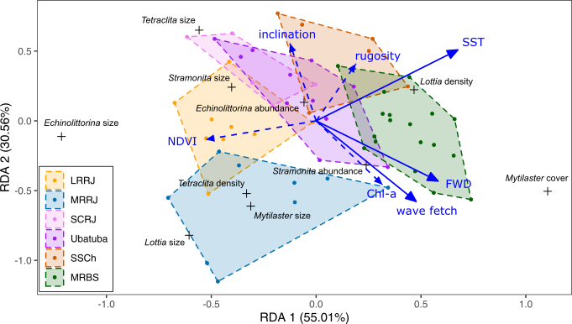

**Figure 2.** Redundancy Analysis (RDA) of environmental drivers and biological indicators of intertidal communities along 62 rocky shores from southwestern Atlantic coast (Brazil). Dashed vectors were not significant in the reduced model. *R2adjusted* = 0.24 for reduced model. MRBS = Baixada Santista; SSCh = São Sebastião Channel; SCRJ = Costa Verde; MRRJ = Rio de Janeiro; LRRJ = Lagos.

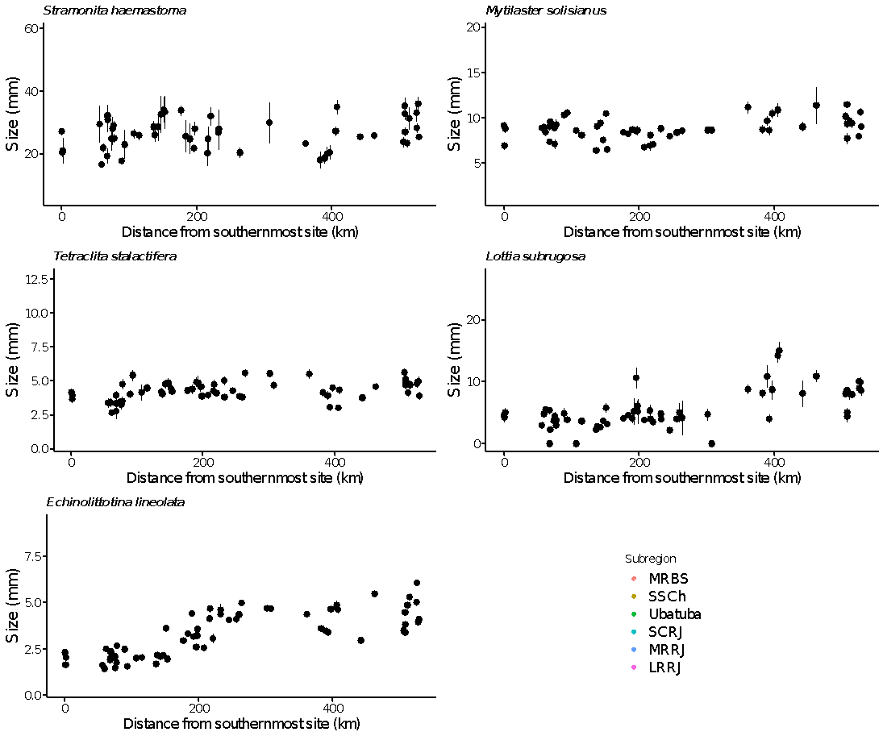

**Figure 3**. Body size variation (mean ± se) of the predator *Stramonita brasiliensis* (a), the preys *Tetraclita* *stalactifera* (b) and *Mytilaster* *solisianus* (c) and the grazing species *Lottia* *subrugosa* (d) and *Echinolittorina* *lineolata* (e) in intertidal environments of 62 rocky shores from the southwestern Atlantic coast (Brazil).

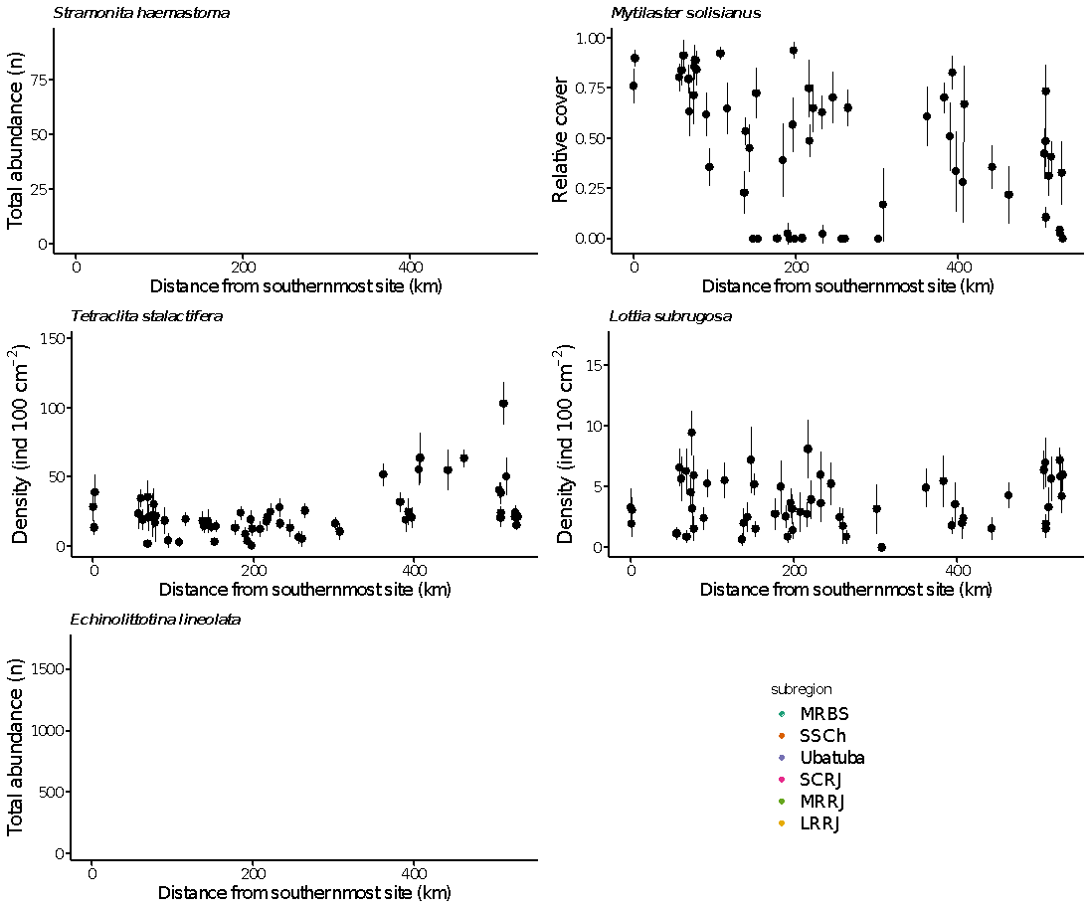

**Figure 4**. Density (mean ± SE) of the predator *Stramonita brasiliensis* (a), the preys *Tetraclita* *stalactifera* (b) and *Mytilaster* *solisianus* (c) and the grazing species *Lottia* *subrugosa* (d) and *Echinolittorina* *lineolata* (e) in intertidal environments of 62 rocky shores from the southwestern Atlantic coast (Brazil). MRBS = Baixada Santista; SSCh = São Sebastião Channel; SCRJ = Costa Verde; MRRJ = Rio de Janeiro; LRRJ = Lagos.

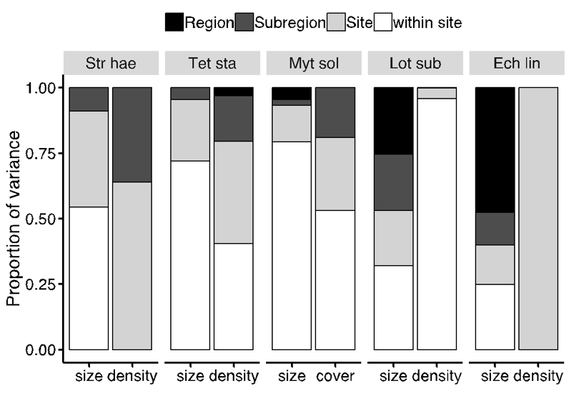

**Figure 5**. Estimates of relative variance component for population parameters (size, density or cover) of the whelk *Stramonita brasiliensis* (Str hae), the barnacle *Tetraclita stalactifera* (Tet sta), the mussel *Mytilaster solisianus* (Mit sol), the limpet *Lottia subrugosa* (Lot sub), and the periwinkle *Echinolittorina lineolata* (Ech nil) in 62 rocky shores along southwestern Atlantic coast (Brazil). Variance components for environmental data were calculated based on averaged values per location for *S. brasiliensis* and *E. lineolata* densities, then there is no data on variation within location.

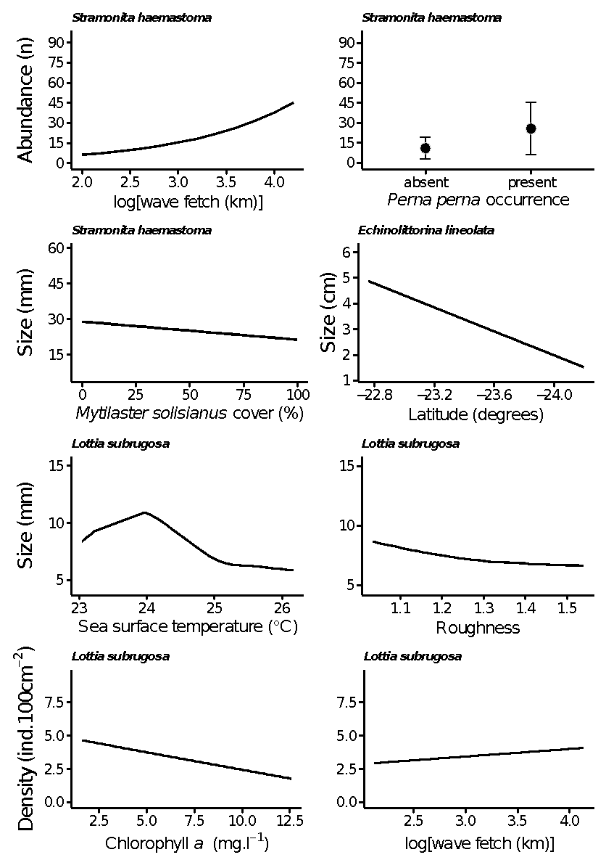

**Figure 6.** Effect of environmental drivers on populational parameters of a intertidal predator (whelk *Stramonita brasiliensis*) and two grazers (limpet *Lottia subrugosa* and periwinkle *Echinolittorina lineolata*) along SE coast of Brazil. Black lines and shaded area represent predictive values of the response ± 95% confidence interval. Dot and whiskers represent the mean and standard deviation, and boxplot represents median (bar), first and third quantiles (box), and the 1.95*interquantile range (whiskers).

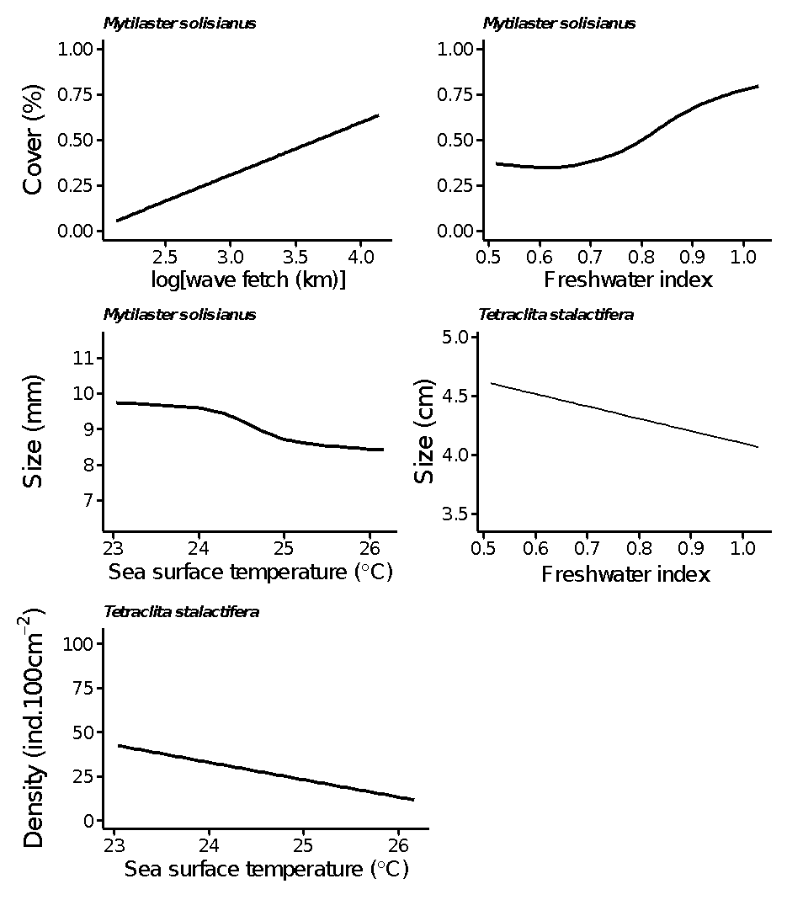

**Figure 7.** Effect of environmental drivers on size and density of intertidal filter feeders and potential prey of the whelk *Stramonita brasiliensis*, the mussel *Mytilaster solisianus* and the barnacle *Tetraclita stalactifera*, along southwestern Atlantic coast (Brazil). Black lines and shaded area represent predictive values of the response ± 95% confidence interval.

**Table 1.** Summary of final models for predator, preys and grazers indicators (dependent variables) tested for effects of biotic and abiotic factors (predictor variables). Spatial models (INLA) differed in the prior for the range of the Matérn spatial correlation function (*i.e*., the distance at which spatial autocorrelation becomes minimal, either 500 or 1000 km). SE = standard error, SD = standard deviation, N = number of observations in models, CI = credible interval, Dev. exp. = deviance explained.

|  |  |  |  |  |  |  |
| --- | --- | --- | --- | --- | --- | --- |
| **Dependent variable** | **Fixed effects** | **Estimate** | **SE** | **Statistic value** | **N** | **Model Parameters** |
| *Stramonita brasiliensis* |  |  |  |  |  | *Random effects* |
| size (LMM) | intercept | 29.44 | 1.31 | 22.46 | 1643 | (variance ± SD) |
|  | *M. solisianus* cover | -0.06 | 0.02 | -2.71** |  | Site: 20.6 ± 4.5 |
|  |  |  |  |  |  |  |
| density (GLM) | intercept | -0.84 | 0.79 | 0.29 | 59 |  |
|  | *P. perna* presence | 0.86 | 0.23 | 4.01*** |  |  |
|  | Wave fetch | 0.90 | 0.21 | 4.16*** |  |  |
| *Mytilaster solisianus* |  |  |  |  |  |  |
| size (GAM) | intercept | 9.76 | 0.38 | 25.78*** | 52 | R2adjusted=0.14, |
|  | s(SST) |  |  | 3.83* |  | Dev. exp.=16.8% |
|  |  |  |  |  |  |  |
| cover (GAM) | intercept | -0.43 | 0.28 | -1.55 | 62 | R2adjusted=0.29, |
|  | Wave fetch | 0.23 | 0.07 | 2.91** |  | Dev. exp.=32.4% |
|  | s(Freshwater index) |  |  | 6.38** |  |  |
| *Tetraclita stalactifera* |  |  |  |  |  |  |
| Size (LM) | intercept | 5.14 | 0.21 | 24.01*** | 60 |  |
|  | Freshwater index | -1.05 | 0.29 | -3.67*** |  |  |
|  |  |  |  |  |  |  |
| Density (INLA) |  | **β** | **CI 95%** |  |  |  |
| *Spatial 500* | intercept | 13.33 | 8.24, 18.62 |  |  | σu = 0.15 |
|  | SST | -0.41 | -0.62, -0.20 |  |  | range = 73 |
| *Spatial 1000* | intercept | 13.53 | 8.38, 18.95 |  |  | σu = 0.15 |
|  | SST | -0.42 | -0.63, -0.21 |  |  | range = 314 |
| *Lottia subrugosa* |  |  |  |  |  |  |
| Size (GAM) | intercept | 7.49 | 0.21 | 35.55*** | 57 | R2adjusted=0.56, |
|  | s(SST) |  |  | 10.51*** |  | Dev. exp.=60.8% |
|  | s(Roughness) |  |  | -3.36* |  |  |
|  |  |  |  |  |  |  |
| Density (INLA) |  | **β** | **CI 95%** |  |  |  |
| *Spatial 500* | intercept | 2.40 | -0.83, 5.67 |  |  | σu = 0.58 |
|  | Chl-a | -0.55 | -0.82, -0.55 |  |  | range = 55.2 |
|  | Wave fetch | 5.73 | 0.28, 11.19 |  |  |  |
| *Spatial 1000* | intercept | 2.44 | -0.86, 5.79 |  |  | σu = 0.58 |
|  | Chl-a | -0.55 | -0.86, -0.25 |  |  | range = 108.8 |
|  | Wave fetch | 5.68 | 0.16, 11.20 |  |  |  |
| *Echinolittorina lineolata* |  |  |  |  |  |  |
| Size (LM) | Intercept only | 3.32 | 0.16 | 21.49*** | 60 |  |
| Density (LMM) | intercept only | 5.04 | 0.06 | 94.68 | 62 |  |

**Full model for predator** (*S. brasiliensis*): *dependent variable* ~ shore extension + shore inclination + wave exposure + SST + roughness + [Chl-a] + NDVI + *T. stalactifera* density + *T. stalactifera* cover + *M. solisianus* cover + *M. solisianus* size + *random term*. **Full model for preys** (*T. stalactifera* and *M. solisianus*): *dependent variable* ~ shore extension + shore inclination + wave exposure + SST + roughness + [Chl-a] + NDVI + *S. brasiliensis* size + *S. brasiliensis* abundance + *random term*. **Full model for grazers** (*L. subrugosa* and *E. lineolata*): *dependent variable* ~ shore extension + shore inclination + wave exposure + SST + roughness + [Chl-a] + NDVI + *random term*. s( ) = smooth term. GAM models *L. subrugosa* size and *T. stalactifera* density were fit to constrained smooth term ‘monotone decreasing P-splines’, and *M. solisianus* cover was fit to ‘monotone increasing P-splines’. *** = p <0.001, ** = p <0.01, * = p <0.05.